Golfing Targets: Average Shot Accuracy (Interval of 2)

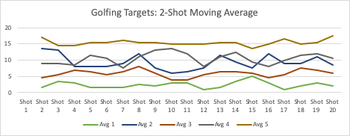

DMack

HW_Task1_Golfing Targets